A

Model Project in **C++**



SHREE H.N. SHUKLA GROUP OF COLLEGES

CLASS :

BCA SEM - 3 B

PREPARED BY :

VAITUL B. BHAYANI

SUBMITED TO:

SHREE H.N. SHUKLA GROUP OF COLLEGES

Introduction to **C++**

C++ is a **multi-paradigm programming language** that **supports object-oriented programming (OOP)**, created by **Bjarne Stroustrup** in **1983** at **Bell Labs**, C++ is an extension(superset) of [C programming](https://www.w3schools.in/c-tutorial/) and the programs are written in C language can run in C++ compilers.

C++ is used by programmers to create computer software. It is used to create general systems software, drivers for various computer devices, software for servers and software for specific applications and also widely used in the creation of video games.

C++ is used by many programmers of different types and coming from different fields. C++ is mostly used to write device driver programs, system software, and applications that depend on direct hardware manipulation under real-time constraints. It is also used to teach the basics of object-oriented features because it is simple and is also used in the fields of research. Also, many primary user interfacesand system files of Windows and Macintosh are written using C++. So, C++ is really a popular, strong and frequently used programming language of this modern programming era.

Definition

A Create and display a project application of STUDENT ADMISSION using inheritance, student name, gender college name, passed stream interested stream,contact no., address etc.

**OUTPUT**

**Starting…**

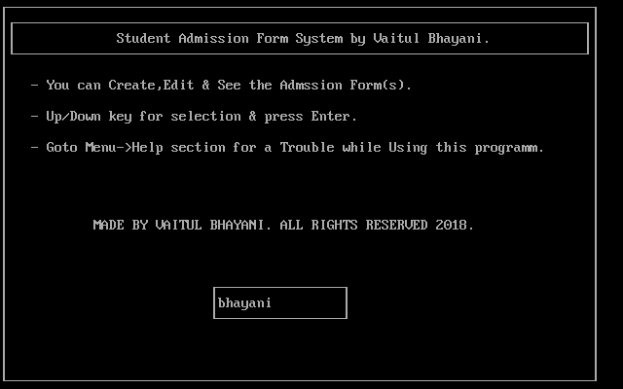

**Home**

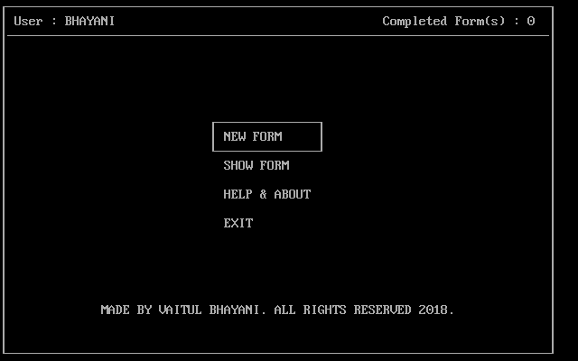

**Home / New Form**

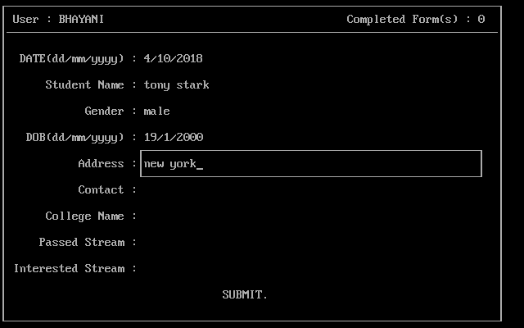

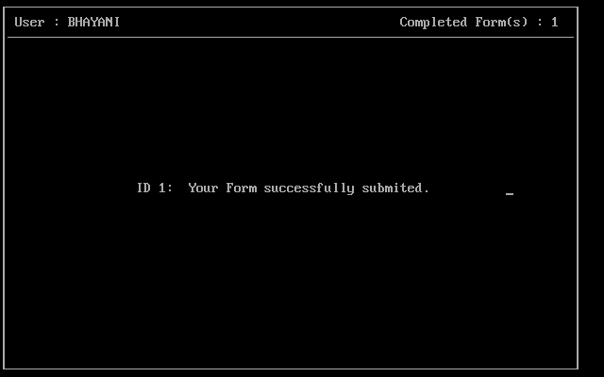

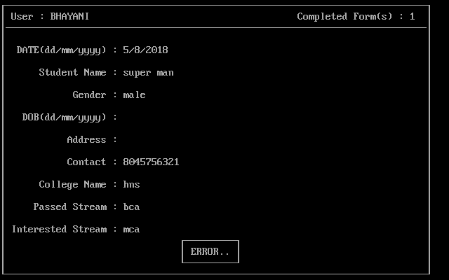

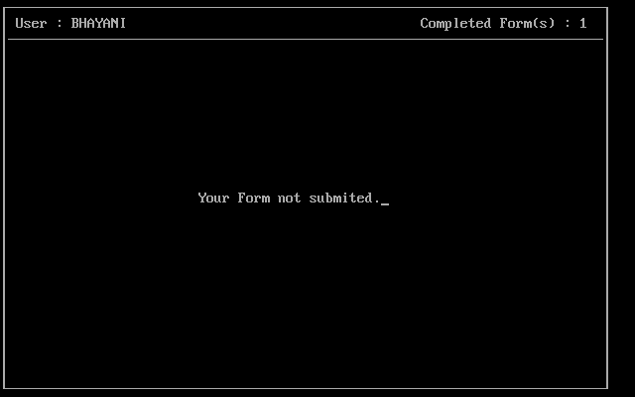

**Home / Show Form**

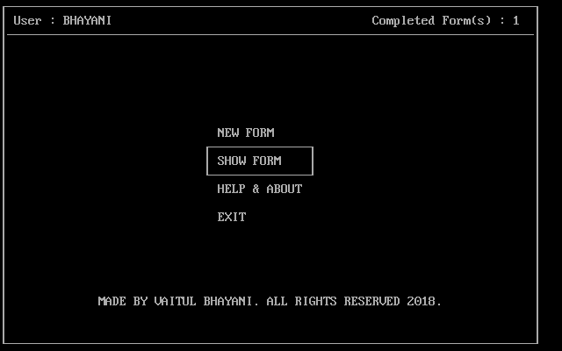

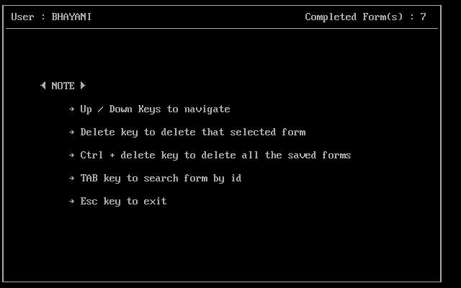

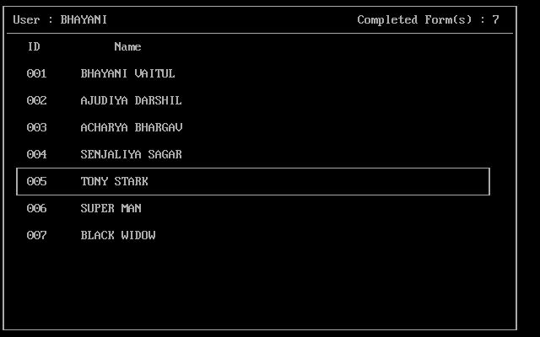

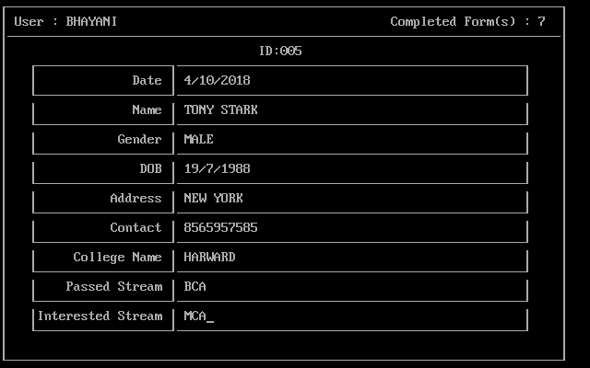



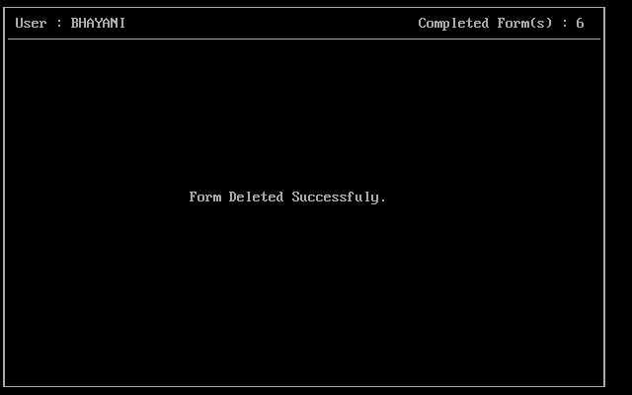

**Home / Help**

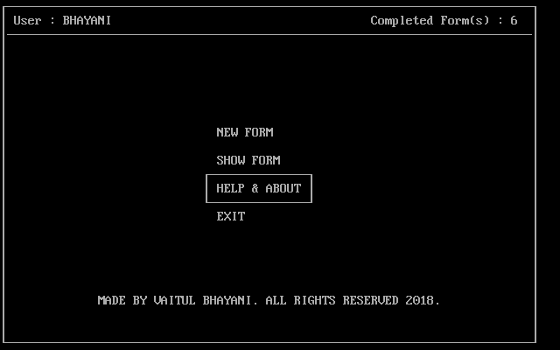

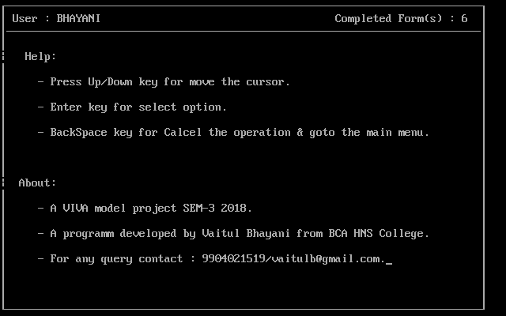

**Behind The OutPut (Codding)**

**#include<stdlib.h>**

**#include<iostream.h>**

**#include<conio.h>**

**#include<dos.h>**

**#include<stdio.h>**

**#include<string.h>**

**#include<fstream.h>**

**// CLASSES**

**class personalInfo**

**{**

**public:**

**char name[30];**

**char gender[7];**

**char dob[15];**

**char address[50];**

**char contact[15];**

**};**

**class careerInfo:public personalInfo**

**{**

**public:**

**char collegeName[30];**

**char passedStream[20];**

**char interestedStream[20];**

**};**

**class studentFormData:public careerInfo**

**{**

**public:**

**int id;**

**char date[15];**

**void setData(char Idate[],**

**char Iname[],char Igender[],char Idob[],**

**char Iaddress[],char Icontact[],**

**char IcollegeName[],char IpassedStream[],**

**char IinterestedStream[])**

**{**

**id = ++ID;**

**strcpy(date,Idate);**

**strcpy( name , Iname);**

**strcpy( gender , Igender);**

**strcpy( dob , Idob);**

**strcpy( address , Iaddress);**

**strcpy( contact , Icontact);**

**strcpy( collegeName , IcollegeName);**

**strcpy( passedStream , IpassedStream);**

**strcpy( interestedStream , IinterestedStream);**

**ofstream fout;**

**fout.open("vb_forms.db",ios::app|ios::binary);**

**fout.write((char*)this,sizeof(*this));**

**fout.close();**

**}**

**void putData(int i)**

**{**

**ifstream fin;**

**fin.open("vb_forms.db",ios::in|ios::binary);**

**if(fin) {**

**fin.read((char*)this,sizeof(*this));**

**while(!fin.eof()){**

**if(id==i)**

**break;**

**fin.read((char*)this,sizeof(*this));**

**}**

**}**

**fin.close();**

**}**

**void deleteForm(int formId)**

**{**

**if(formId>ID) {**

**clrscr();**

**cout<<"dev error : Id Not Found";**

**getch();**

**return;**

**}**

**if(!(formId==-1||formId==1&&ID==1)) {**

**ifstream fin;**

**ofstream tmp;**

**fin.open("vb_forms.db",ios::in|ios::binary);**

**tmp.open("vb_temp.dat",ios::app|ios::binary);**

**fin.read((char*)this,sizeof(*this));**

**int tid=1;**

**while(!fin.eof()){**

**if(this->id!=formId) {**

**this->id = tid;**

**tmp.write((char*)this,sizeof(*this));**

**tid++;**

**}**

**fin.read((char*)this,sizeof(*this));**

**}**

**fin.close();**

**tmp.close();**

**remove("vb_forms.db");**

**rename("vb_temp.dat","vb_forms.db");**

**}**

**else**

**remove("vb_forms.db");**

**frame();**

**animatedWord(25,13,"Form Deleted Successfuly.");**

**delay(1500);**

**}**

**};**

**// FUNTIONS**

**char name[100];**

**int selection=1,re=9,WFLAG=0;**

**void Box();//print the border around th text.**

**void removeBox();//remove the border around th text.**

**void frame();//print the border around whole window and top panel.**

**void menu();//menu declaration & and there conding.**

**void welcome();//print the first text when we programm start.**

**void newForm();//make new admission form.**

**void showForm();//show form.**

**void help();//programm help section**

**void start(int);//starting function of all another functions**

**void animatedWord(int x,int y,char[],int=1);//print animated str.**

**void Box(int x=0,int y=0,int w=0,int h=1)**

**{**

**gotoxy(x+0,y+0);**

**cout << char (218);//top left corner**

**for(int i=1;i<=h;i++){**

**gotoxy(x+0,y+i);**

**cout << char (179);// |**

**}**

**gotoxy(x+0,y+1+h);**

**cout << char (192);//bottom left corner**

**gotoxy(x+1,y+0);**

**for(i=1;i<=1+w;i++)**

**cout << char (196);// -**

**cout << char (191);//top right corner**

**for(i=1;i<=h;i++)**

**{**

**gotoxy(x+2+w,y+i);**

**cout << char (179);// |**

**}**

**gotoxy(x+1,y+1+h);**

**for(i=1;i<=1+w;i++)**

**cout << char (196);// -**

**cout << char (217);//bottom right corner**

**}**

**void removeBox(int x=0,int y=0,int w=0,int h=1)**

**{**

**gotoxy(x+0,y+0);**

**cout << " ";//top left corner**

**for(int i=1;i<=h;i++){**

**gotoxy(x+0,y+i);**

**cout << " ";// |**

**}**

**gotoxy(x+0,y+1+h);**

**cout << " ";//bottom left corner**

**gotoxy(x+1,y+0);**

**for(i=1;i<=1+w;i++)**

**cout << " ";// -**

**cout << " ";//top right corner**

**for(i=1;i<=h;i++){**

**gotoxy(x+2+w,y+i);**

**cout << " ";// |**

**}**

**gotoxy(x+1,y+1+h);**

**for(i=1;i<=1+w;i++)**

**cout << " ";// -**

**cout << " ";//bottom right corner**

**}**

**void frame()**

**{**

**clrscr();**

**Box(1,1,74,1);**

**Box(1,1,74,23);**

**gotoxy(2,2);**

**cout<< " User : ";**

**cout << (name);**

**gotoxy(54,2);**

**ifstream fin;**

**fin.open("vb_forms.db",ios::in|ios::binary);**

**if(fin) {**

**char tmp[204];**

**ID=0;**

**fin.read(tmp,sizeof(studentFormData));**

**while(!fin.eof()){**

**fin.read(tmp,sizeof(studentFormData));**

**ID++;**

**}**

**fin.close();**

**}**

**else**

**ID=0;**

**cout << "Completed Form(s) : ";cout << ID;cout;**

**}**

**void menu(int selection=0,int flag=0)**

**{**

**if(!flag) {**

**switch(selection) {**

**case 0:break;**

**case 1:Box(30,9,13,1);break;**

**case 2:Box(30,11,13,1);break;**

**case 3:Box(30,13,13,1);break;**

**case 4:Box(30,15,13,1);break;**

**}**

**gotoxy(32,10);**

**cout << "NEW FORM";**

**gotoxy(32,12);**

**cout << "SHOW FORM";**

**gotoxy(32,14);**

**cout << "HELP & ABOUT";**

**gotoxy(32,16);**

**cout << "EXIT";**

**gotoxy(37,26);**

**}**

**else**

**switch(selection)**

**case 0:break;**

**case 1:newForm();break;**

**case 2:showForm();break;**

**case 3:help();break;**

**case 4:clrscr();**

**gotoxy(35,12);**

**cout<<"THANK YOU.\n\t\t\t\t ";**

**delay(2000);exit(1);break;**

**}**

**start(0);**

**}**

**}**

**void welcome()**

**{**

**ifstream fin;**

**fin.open("vb_user.db");**

**if(!fin) {**

**Box(1,1,74,23);**

**gotoxy(0,0);**

**Box(2,2,72);**

**char f[] = "Student Admission Form System by Vaitul**

**Bhayani.";**

**char s[] = "- You can Create,Edit & See the Admssion**

**Form(s).";**

**char t[] = "- Up/Down key for selection & press Enter.";**

**char fo[] = "- Goto Menu->Help section for a Trouble**

**while Using this programm.";**

**animatedWord(16,3,f);**

**animatedWord(5,6,s);**

**animatedWord(5,8,t);**

**animatedWord(5,10,fo);**

**char rights[] = "MADE BY VAITUL BHAYANI. ALL RIGHTS**

**RESERVED 2018.";**

**animatedWord(13,15,rights);**

**Box(30,19,10);**

**gotoxy(31,20);**

**char btn[] = "Get Started";**

**cout << (btn);**

**gotoxy(0,21);**

**getch();**

**gotoxy(43,20);**

**//Getting name from user.**

**cout << "\b\b\b\b\b\b\b\b\b\b\b\b\b\bEnter Name Only";**

**Box(28,19,15);**

**gotoxy(44,20);delay(1500);gotoxy(29,20);cout << " ";**

**gotoxy(29,20);**

**fflush(stdin);**

**cin>>(name);**

**strcpy(name,strupr(name));**

**ofstream fout;**

**fout.open("vb_user.db");**

**fout.write(name,sizeof(name));**

**fout.close();**

**}**

**else**

**{**

**fin.read(name,sizeof(name));**

**fin.close();**

**}**

**}**

**studentFormData addmisionForm;**

**void newForm()**

**{**

**frame();**

**char f[]="Please fill up all fields.";**

**animatedWord(26,13,f);**

**delay(1000);animatedWord(26,13,f,0);**

**gotoxy(1,3);**

**char data[10][100];**

**strcpy(data[0] , " DATE(dd/mm/yyyy) : ");**

**strcpy(data[1] , " Student Name : ");**

**strcpy(data[2] , " Gender : ");**

**strcpy(data[3] , " DOB(dd/mm/yyyy) : ");**

**strcpy(data[4] , " Address : ");**

**strcpy(data[5] , " Contact : ");**

**strcpy(data[6] , " College Name : ");**

**strcpy(data[7] , " Passed Stream : ");**

**strcpy(data[8] , "Interested Stream : ");**

**for(int i=0,j=5;i<=8;i++,j+=2) {**

**animatedWord(3,j,data[i]);**

**}**

**gotoxy(35,23);**

**cout<<"SUBMIT.";**

**for(i=0,j=0;i<=16,j<=8;i+=2,j++){**

**Box(22,4+i,50);**

**gotoxy(23,4+1+i);**

**fflush(stdin);**

**gets(data[j]);**

**removeBox(22,4+i,50);**

**strupr(data[j]);**

**}**

**int flag=1;**

**for(i=0;i<=8;i++){**

**if(!data[i][0]) {**

**flag = 0;**

**break;**

**}**

**}**

**Box(33,22,8);**

**if(!flag){**

**gotoxy(35,23);**

**cout<<"ERROR.";**

**getch();**

**frame();**

**char f[] ="Your Form not submited.";**

**animatedWord(26,13,f);**

**delay(2300);animatedWord(26,13,f,0);**

**return;**

**}**

**getch();**

**addmisionForm.setData(data[0],data[1],data[2],**

**data[3],data[4],data[5],**

**data[6],data[7],data[8]);**

**frame();**

**gotoxy(19,13);cout << "ID "<<ID<<":";**

**char f1[]=" Your Form successfully submited. ";**

**animatedWord(25,13,f1);delay(2000);**

**animatedWord(19,13,f1,0);**

**}**

**int flag_showform = 1;**

**void showForm()**

**{**

**ifstream fin;**

**fin.open("vb_forms.db");**

**if(!fin)**

**frame();**

**char f[] ="Sorry ,Form not Found !!";**

**animatedWord(27,13,f);delay(1500);**

**animatedWord(27,13,f,0);**

**return;**

**}**

**if(flag_showform) {**

**frame();**

**gotoxy(8,8);**

**cout<<char(17)<<" NOTE "<<char(16);**

**gotoxy(13,10);**

**cout<<char(26)<<" Up / Down Keys to navigate";**

**gotoxy(13,12);**

**cout<<char(26)<<" Delete key to delete that selected**

**form";**

**gotoxy(13,14);**

**cout<<char(26)<<" Ctrl + delete key to delete all**

**the saved forms";**

**gotoxy(13,16);**

**cout<<char(26)<<" TAB key to search form by id";**

**gotoxy(13,18);**

**cout<<char(26)<<" Esc key to exit";**

**getch();**

**flag_showform = 0;**

**}**

**studentFormData form;**

**int sel=0;**

**if(ID<1){**

**frame();**

**char f[] ="Sorry ,Form not Found !!";**

**animatedWord(27,13,f);delay(1500);**

**animatedWord(27,13,f,0);**

**return;**

**}**

**else if(ID<2)**

**frame();**

**char f[]=" One Form Found.";**

**animatedWord(27,13,f);delay(1500);**

**animatedWord(27,13,f,0);**

**sel = 1;**

**}**

**Else**

**{**

**frame();**

**int i=1,x=5,y=6,step=10,flag = 1,c;**

**sel = 5;**

**gotoxy(5,4);cout << "ID Name ";**

**RESTART:**

**for(i;i<=step;i++){**

**if(i<=ID) {**

**gotoxy(x,y);**

**form.putData(i);**

**printf("%.3d ",form.id);**

**if(i == step || sel < 10)**

**animatedWord(x+8,y,form.name);**

**else**

**cout << form.name;**

**y+=2;**

**}**

**}**

**i--;**

**if((i-step) == 0)**

**{**

**while(1)**

**{**

**if(flag)**

**{**

**Box(x-2,sel,68);**

**c = getch();**

**if(c == 224 || c==0)**

**c = getch();**

**if(c == 80)**

**{**

**if(sel<7)**

**{**

**char f[] = " ";**

**gotoxy(36,3);**

**cout << f;**

**}**

**removeBox(x-2,sel,68);**

**if((sel-3)/2<ID)**

**sel += 2;**

**Box(x-2,sel,68);**

**}**

**if(c == 72)**

**{**

**if(sel<7){char f[] = " ";**

**gotoxy(36,3);cout << f;}**

**removeBox(x-2,sel,68);**

**if((sel-3)/2<ID)**

**sel += 2;**

**Box(x-2,sel,68);**

**}**

**gotoxy(36,3);**

**for(int k=1;k<=40;k++){cout<<char(196);}**

**}**

**if((sel-3)/2 == step)**

**{**

**flag = 0;**

**c = getch();**

**if(c == 224)**

**c = getch();**

**if(c == 80)**

**{**

**sel+=2;**

**x=5;y=6;**

**gotoxy(x,y);**

**step++;**

**i = step - 10;**

**i++;**

**if((sel-3)/2 <= ID)**

**goto RESTART;**

**}**

**}**

**if(c == 83)**

**{**

**form.deleteForm((sel-3)/2);**

**return;**

**}**

**if(c == 147)**

**{**

**form.deleteForm(-1);**

**return;**

**}**

**if(c == 27)**

**return;**

**if(c == 13)**

**{**

**sel = (sel-3)/2;**

**if(sel>=ID)**

**sel = ID;**

**break;**

**}**

**if(c == 9)**

**{**

**frame();**

**char f[] = "Enter ID Number : ";**

**animatedWord(19,13,f);**

**Box(37,12,4);**

**char s[] = " And press enter.";**

**animatedWord(44,13,s);**

**gotoxy(39,13);**

**int q;**

**cin >> q;**

**if(q>ID)**

**{**

**frame();**

**char t[] = "Entered ID has not found!";**

**animatedWord(25,13,t);**

**delay(2000);**

**animatedWord(25,13,f,0);**

**showForm();**

**return;**

**}**

**sel = q;**

**break;**

**}**

**}**

**}**

**}**

**frame();**

**gotoxy(36,4);**

**printf("ID:%.3d",sel);**

**form.putData(sel);**

**int x = 23;**

**for(int i=16;i>=0;i-=2)**

**{**

**Box(x+1,i+5,46,1);**

**Box(x-18,i+5,17,1);**

**}**

**int y = 6;**

**gotoxy(6,y);cout<<" Date";**

**gotoxy(6,y+2);cout<<" Name";**

**gotoxy(6,y+4);cout<<" Gender";**

**gotoxy(6,y+6);cout<<" DOB";**

**gotoxy(6,y+8);cout<<" Address";**

**gotoxy(6,y+10);cout<<" Contact";**

**gotoxy(6,y+12);cout<<" College Name";**

**gotoxy(6,y+14);cout<<" Passed Stream";**

**gotoxy(6,y+16);cout<<"Interested Stream";**

**x=26;**

**y=6;**

**gotoxy(x,y);cout<<form.date;**

**gotoxy(x,y+2);cout<<form.name;**

**gotoxy(x,y+4);cout<<form.gender;**

**gotoxy(x,y+6);cout<<form.dob;**

**gotoxy(x,y+8);cout<<form.address;**

**gotoxy(x,y+10);cout<<form.contact;**

**gotoxy(x,y+12);cout<<form.collegeName;**

**gotoxy(x,y+14);cout<<form.passedStream;**

**gotoxy(x,y+16);cout<<form.interestedStream;**

**gotoxy(x+12,y+20);**

**int c = getch();**

**if(c==0 && getch()== 83)**

**form.deleteForm(sel);**

**if(ID<2)**

**return;**

**showForm();**

**}**

**void animatedWord(int x,int y,char tmp[],int F)**

**{**

**gotoxy(x,y);**

**for(int i=0;tmp[i]!='\0';i++)**

**{**

**delay(7);**

**if(F)**

**cout << tmp[i];**

**else**

**cout << " ";**

**}**

**}**

**void help()**

**{**

**frame();**

**cout << "\n\n\n| Help:";**

**char f[] = " - Press Up/Down key for move the cursor.";**

**char s[] = " - Enter key for select option.";**

**char t[] = " - BackSpace key for Calcel the operation &**

**goto the main menu.";**

**animatedWord(6,7,f);**

**animatedWord(6,9,s);**

**animatedWord(6,11,t);**

**cout << "\n\n\n\n| About:";**

**char f1[] = " - A VIVA model project SEM-3 2018.";**

**char s1[] = " - A programm developed by Vaitul Bhayani**

**from BCA HNS College.";**

**char t1[] = " - For any query contact :**

**9904021519/vaitulb@gmail.com.";**

**animatedWord(6,17,f1);**

**animatedWord(6,19,s1);**

**animatedWord(6,21,t1);**

**getch();**

**}**

**void start(int f)**

**{**

**WFLAG = f;**

**if(WFLAG!=0){**

**frame(); char c[] ="MADE BY VAITUL BHAYANI.ALL**

**RIGHTS RESERVED 2018.";**

**animatedWord(15,22,c);**

**}**

**while(WFLAG)**

**{**

**menu(selection);**

**if(getch() == 13){menu(selection,1);}**

**else**

**{**

**removeBox(30,re,13,1);**

**switch(getch())**

**{**

**case 72:**

**selection--;**

**re -= 2;**

**break;**

**case 80:**

**selection++;**

**re += 2;**

**break;**

**}**

**if(selection>4){selection--; re -= 2;}**

**if(selection<1){selection++; re += 2;}**

**}**

**}**

**}**

**void main()**

**{**

**clrscr();**

**welcome();**

**while(1)**

**{**

**fflush(stdin);**

**start(1);**

**}**

**}**

Thank You